|  |  |  |
| --- | --- | --- |
|  | 7.SINIF İNSANDA ÜREME, BÜYÜME VE GELİŞME TESTİ |  |
|  |  |  |
|  |  |  |

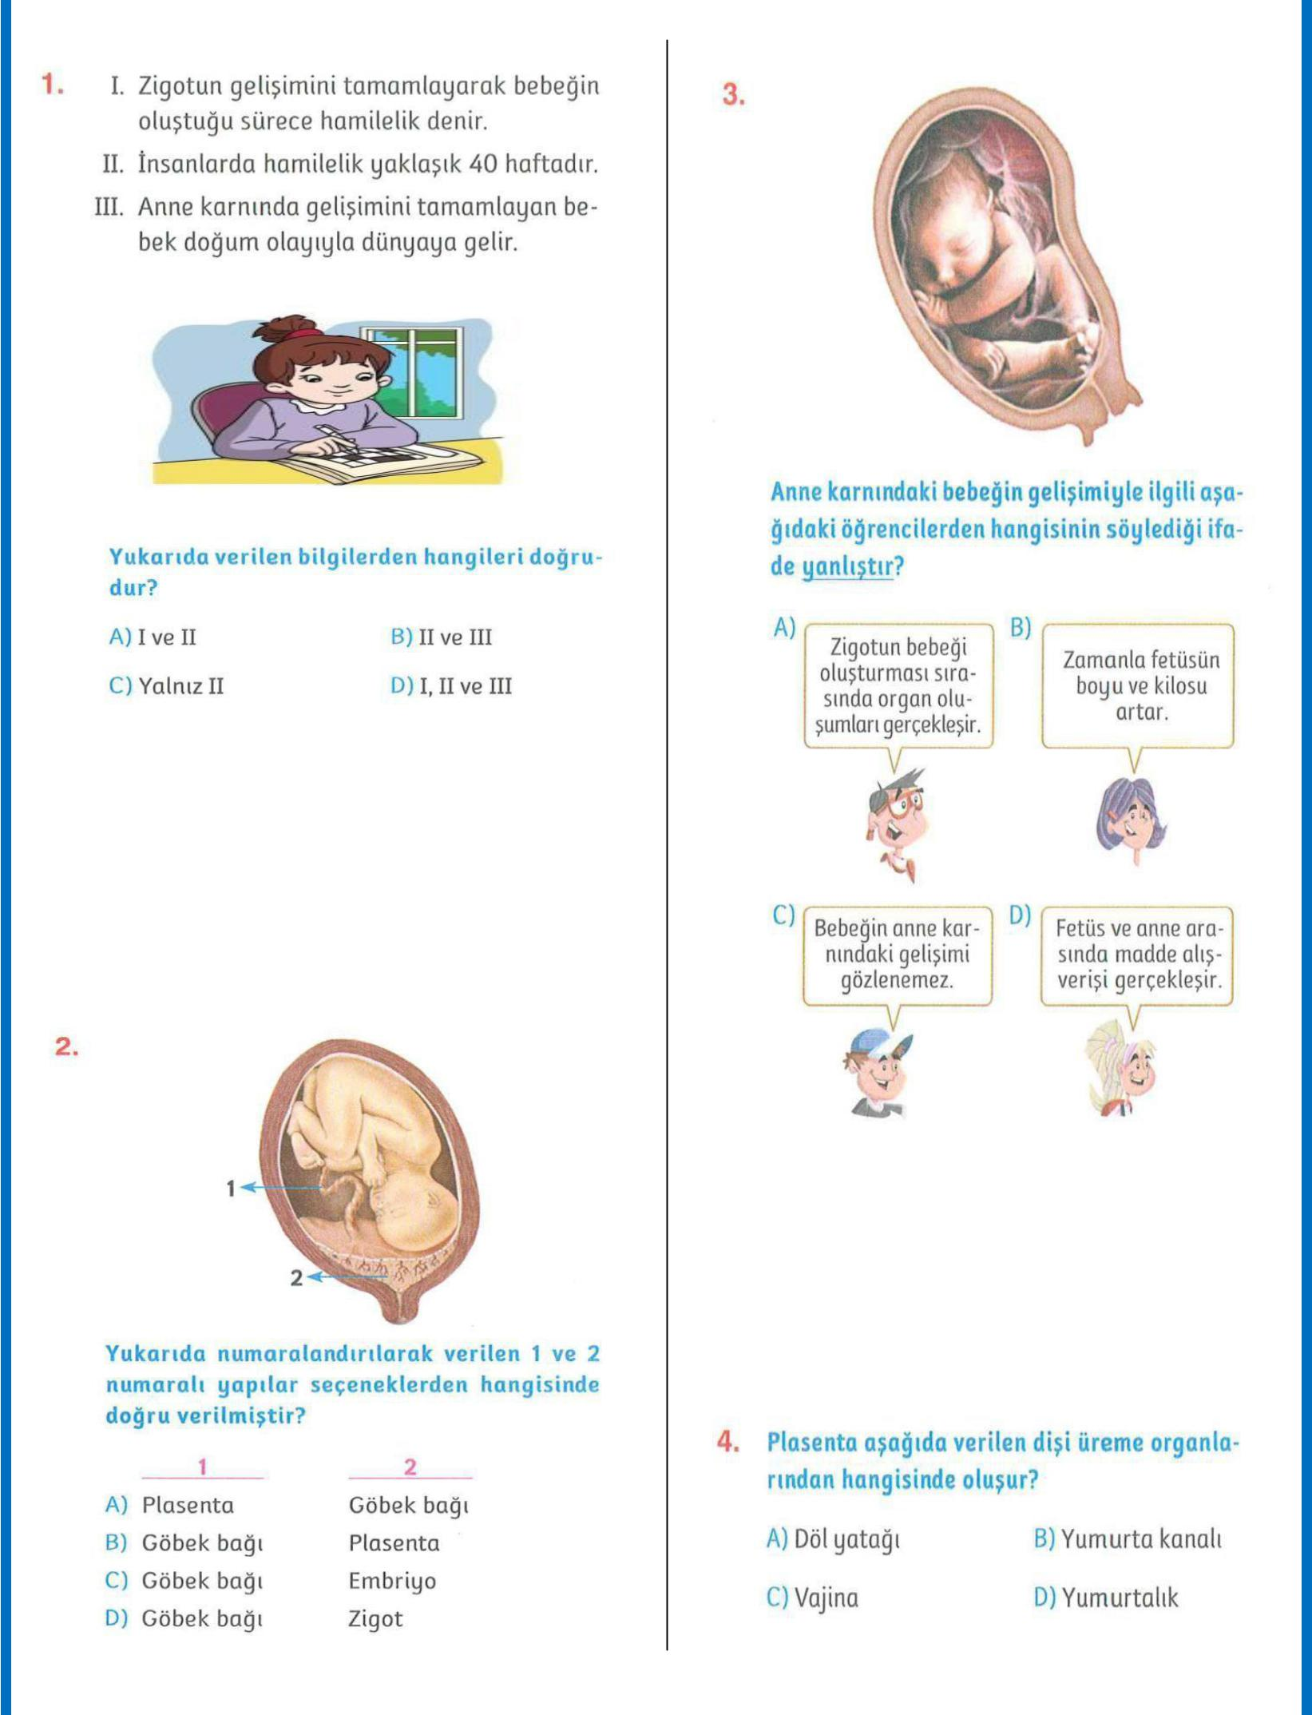

1

|  |  |  |
| --- | --- | --- |
|  |  |  |
|  |  |  |
|  |  |  |

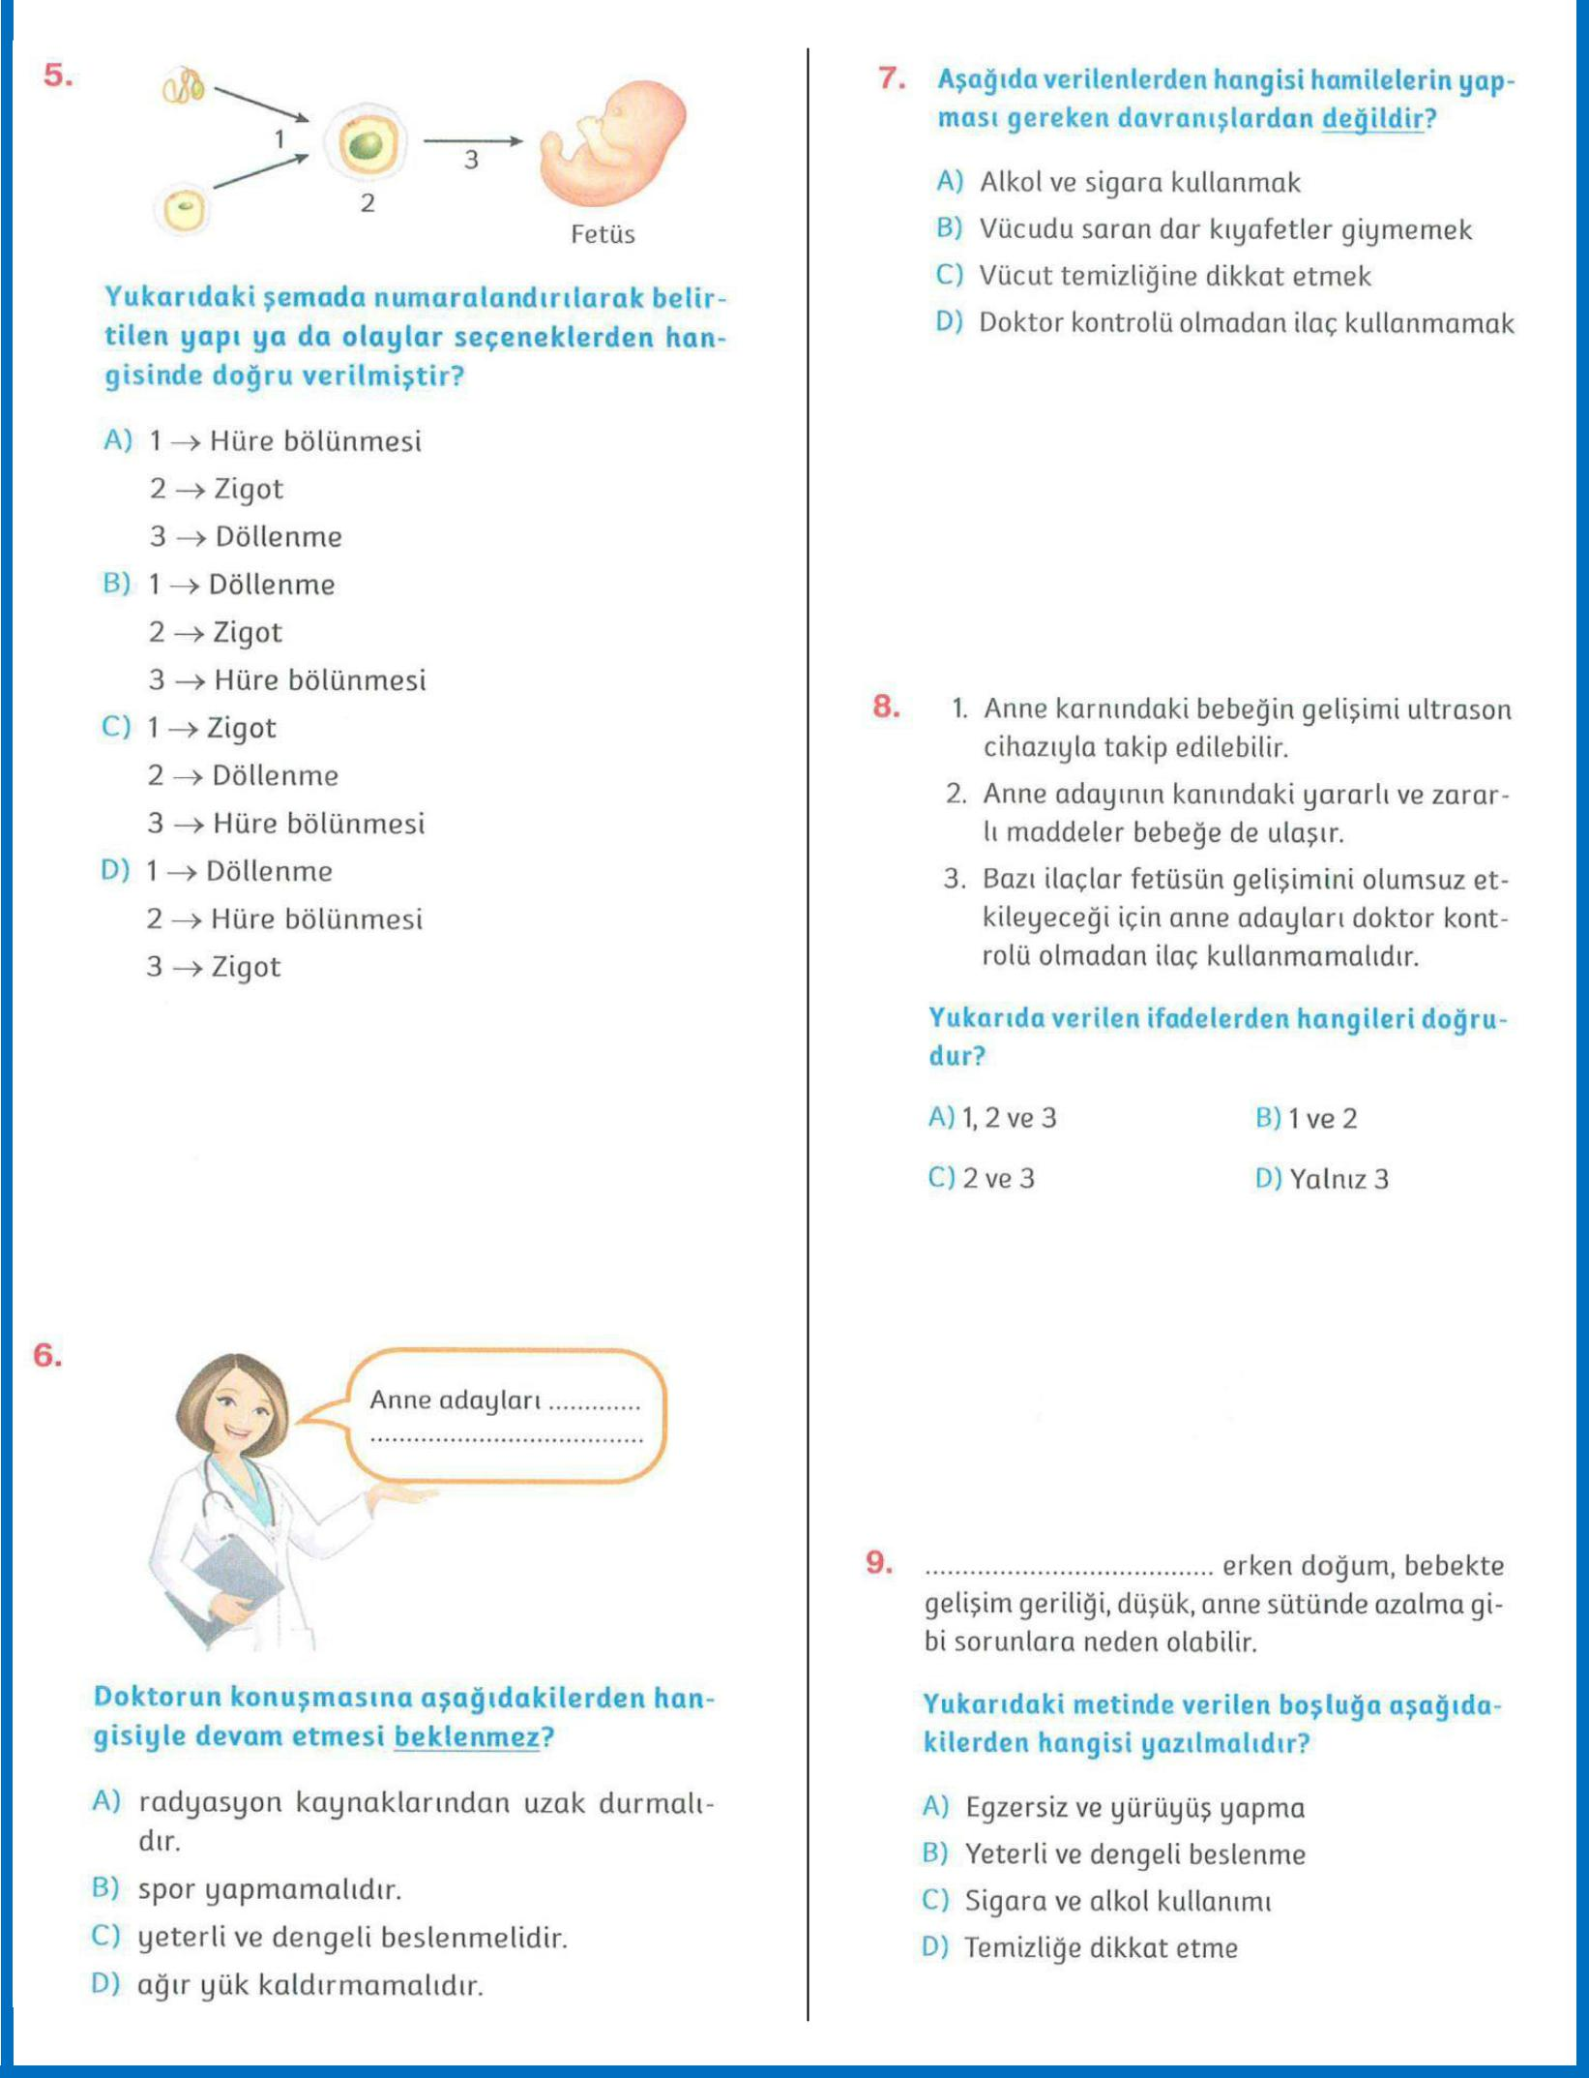

2

|  |  |  |
| --- | --- | --- |
|  |  |  |
|  |  |  |
|  |  |  |

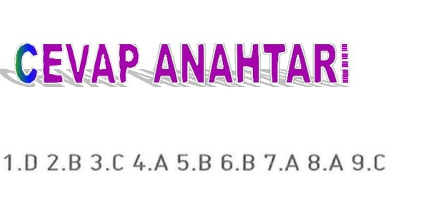

3