|  |  |  |
| --- | --- | --- |
|  | 7.SINIF İNSANDA ÜREME,BÜYÜME VE GELİŞME TESTİ 2 |  |
|  |  |  |
|  |  |  |

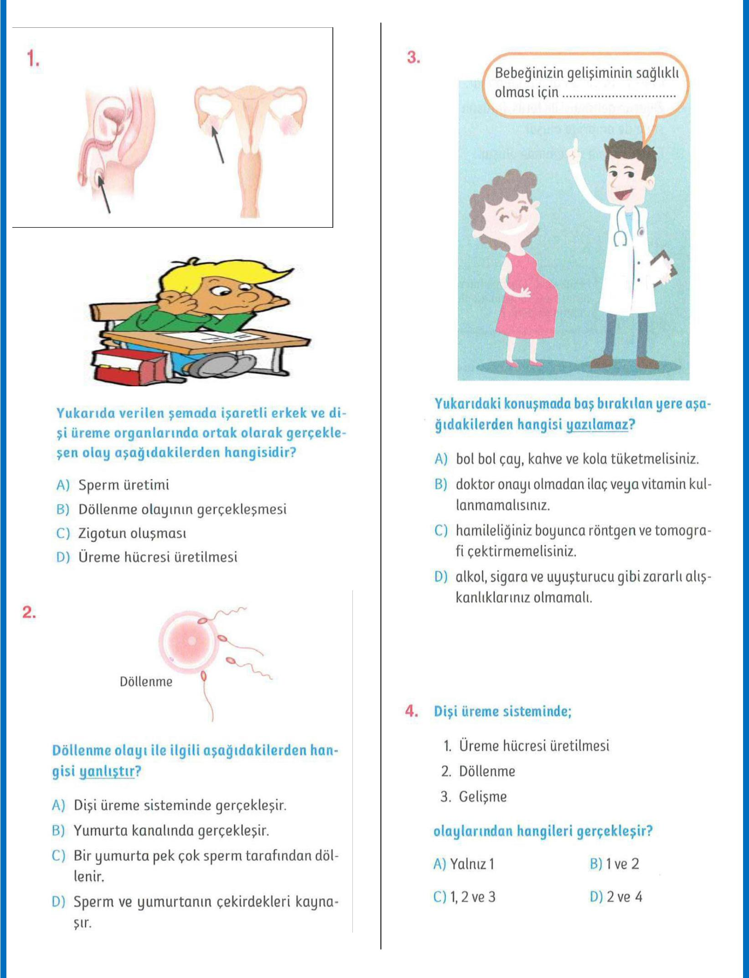

1

|  |  |  |
| --- | --- | --- |
|  |  |  |
|  |  |  |
|  |  |  |

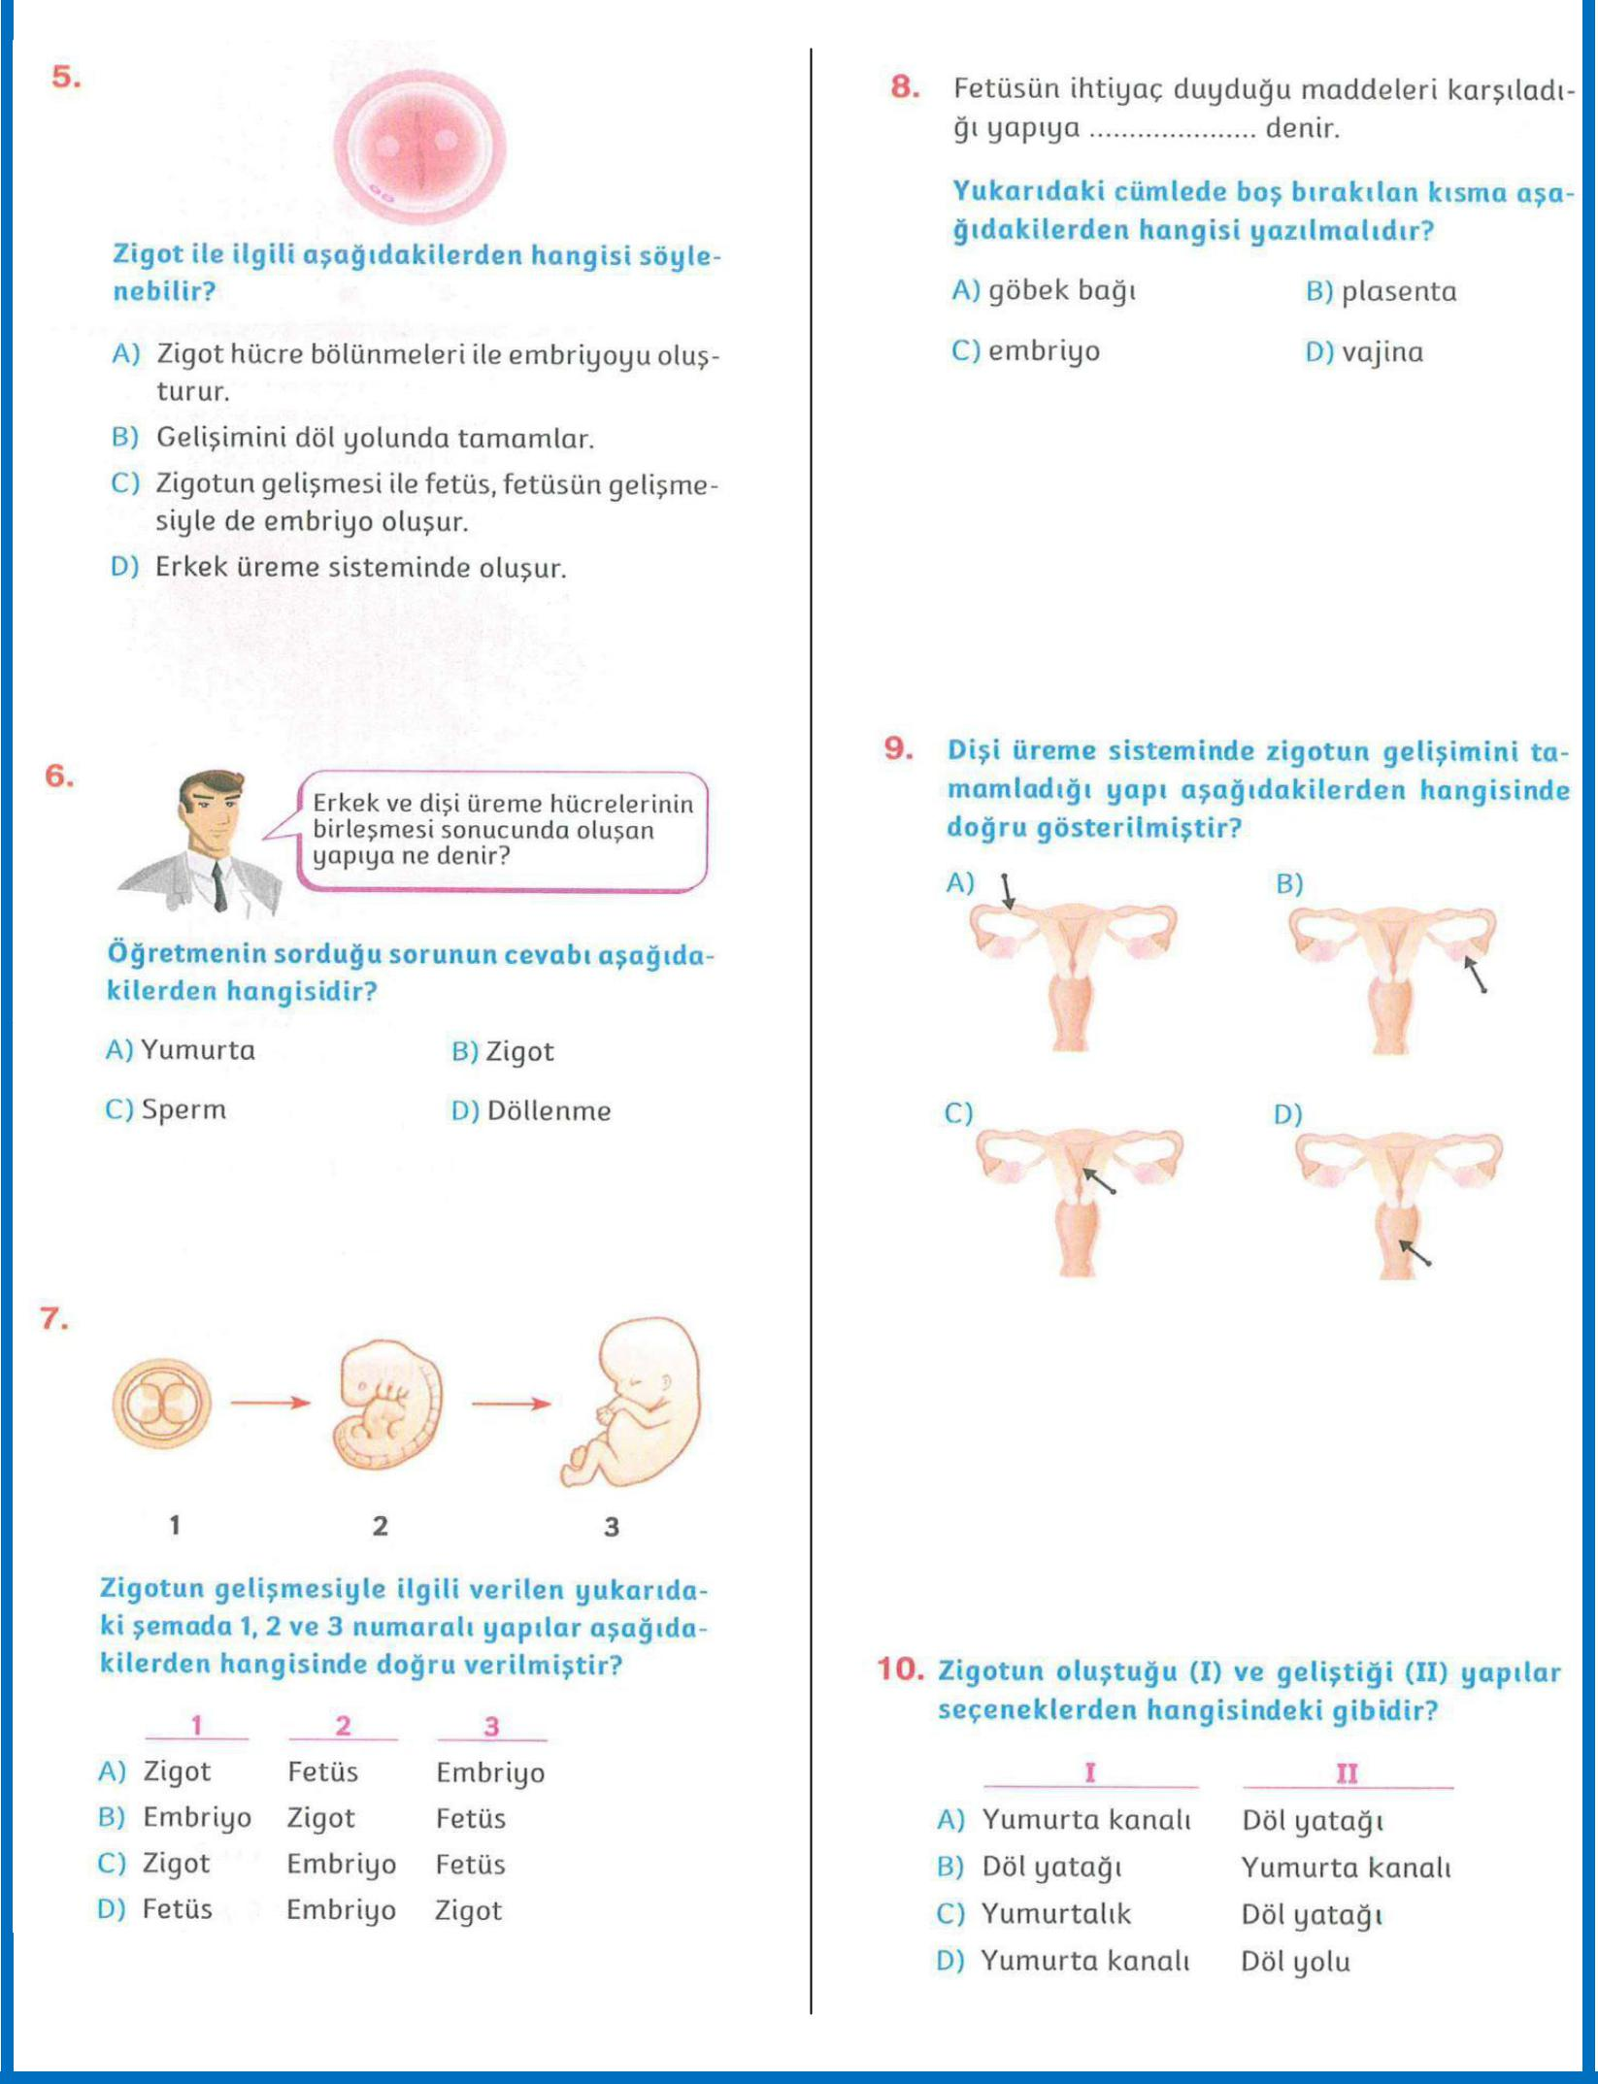

2

|  |  |  |
| --- | --- | --- |
|  |  |  |
|  |  |  |
|  |  |  |

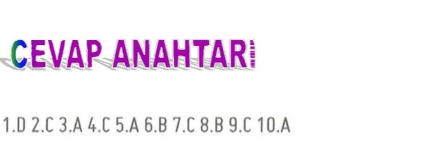

3